Put the expert into the Experts folder of MT4
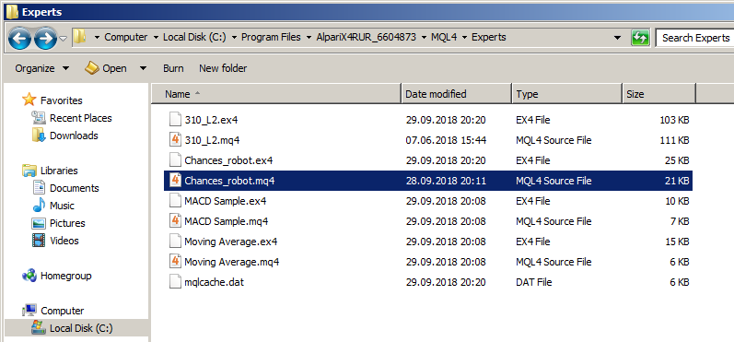
Put the indicator into the Indicators folder of MT4
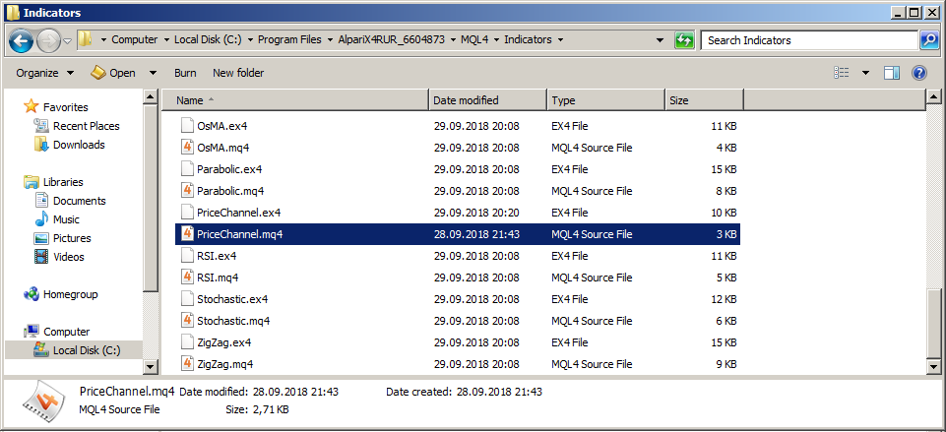
Open the Metatrader terminal and enter the MetaEditor (press F4). Locate both the indicator and expert in the navigation pane and compile them – press F7 or the Compile button to compile each one.
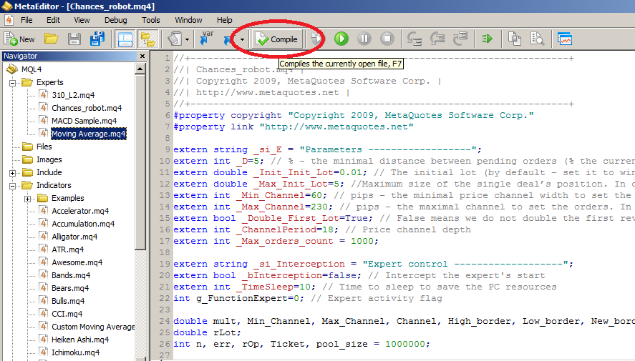
If you would like to do some tests, go to the History center to download the quotes history
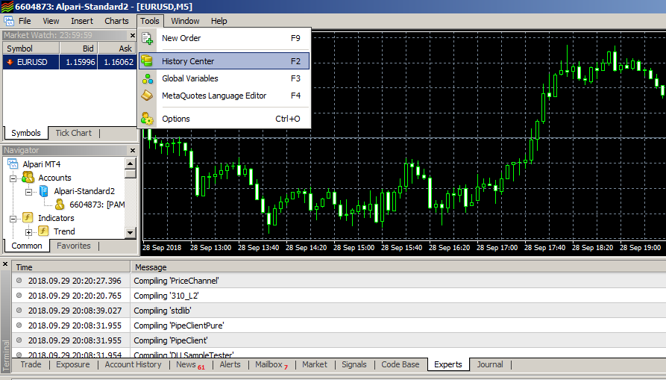
In the history center select an instrument, doubleclick 1 Minute (1M) under it, and press Download.
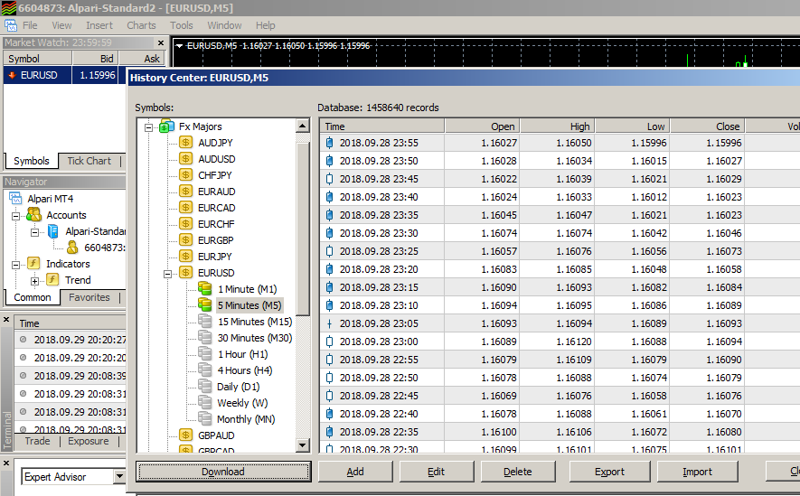
Open Strategy tester, choose the Symbol, the timeframe (M5 and greater is recommended), tmodel shown below, market spread for the chosen instrument, and period for testing. Press Start.
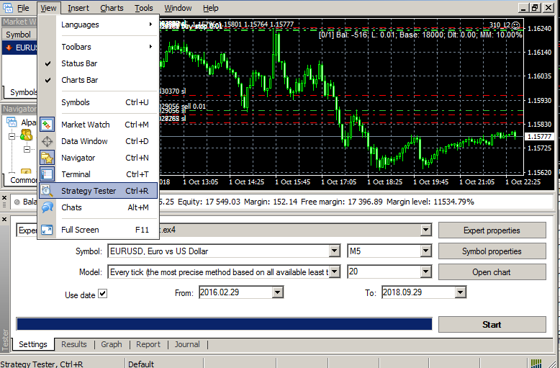
Once you’re happy with the test result, put you’re your expert onto the current chart with a doubleclick on its name in the Navigator. Adjust parameters, if required, run and enjoy.
